**Sprint Boot Explanation and Configuration for Basic Web Project**

**Existing Maven approach and Spring Boot approach for GAV coordinates**

Just 1 GAV co-ordinate will take care of the entire dependencies

For Web – only 1 GAV co-ordinate

For Spring Security – only 1 GAV co-ordinate

For DB Sprint Security – only 1 GAV co-ordinate etc.

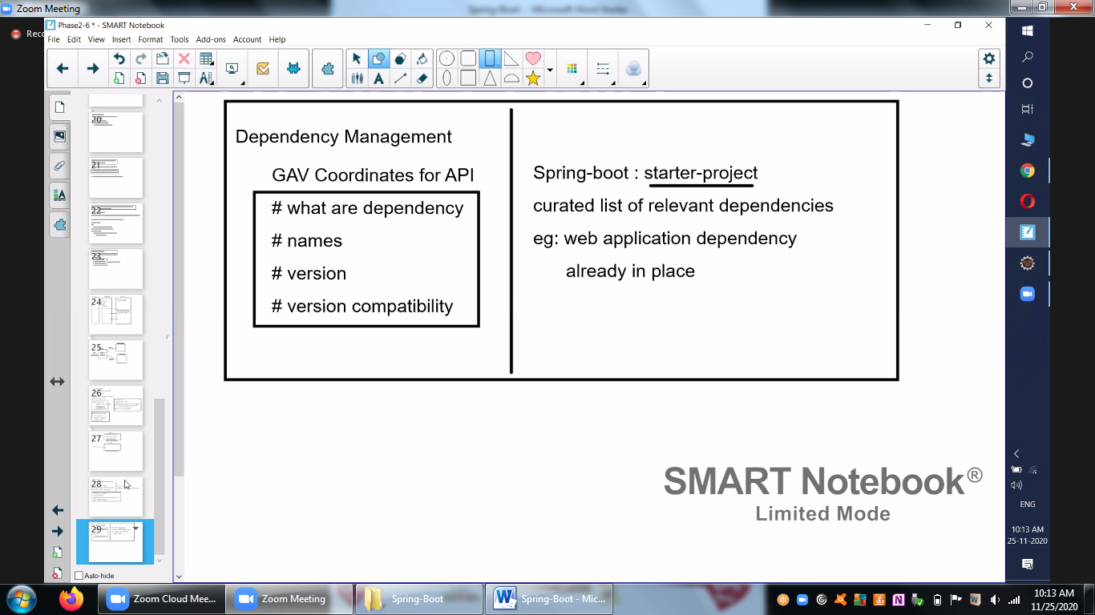

**Auto Configuration**

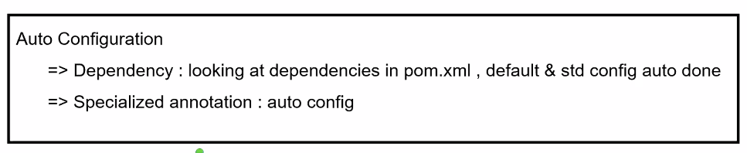

**Properties file is a key feature for Spring-Boot**

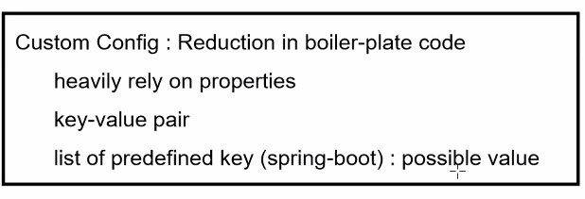

**Self-Sufficient**

**Current Approach**

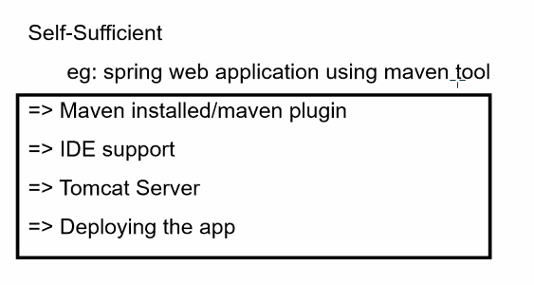

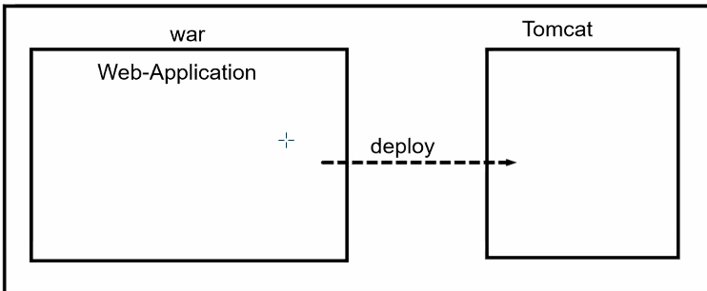

**Spring-Boot Approach**

Independent and help us to get all the things to get easily, Most of them are in-built

Simple Java file will take care of all the aspects

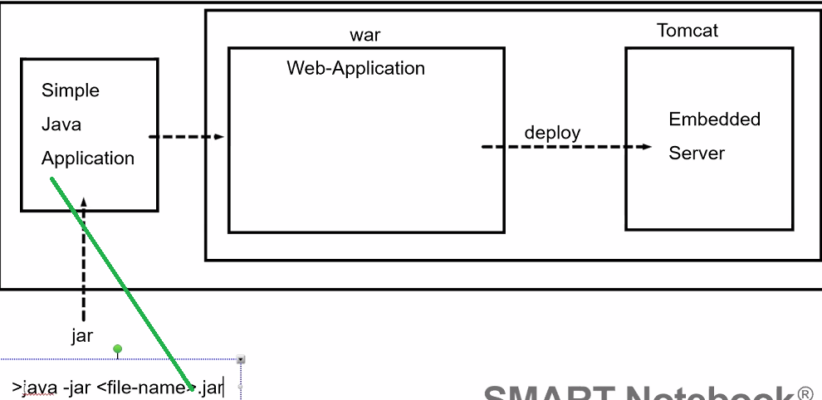

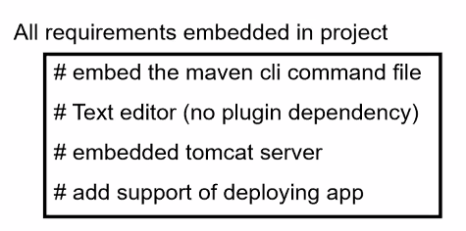

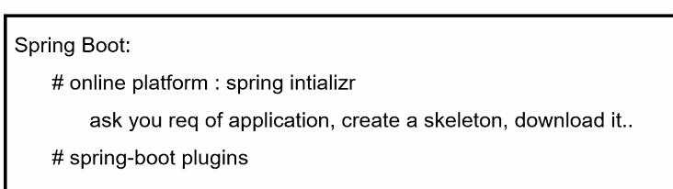

Online Spring platform

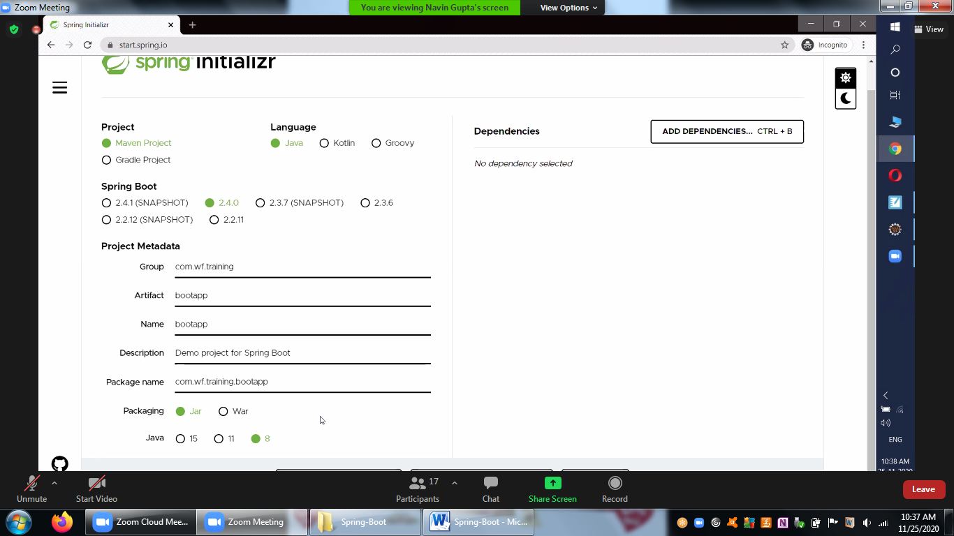

Click on the Add Dependencies

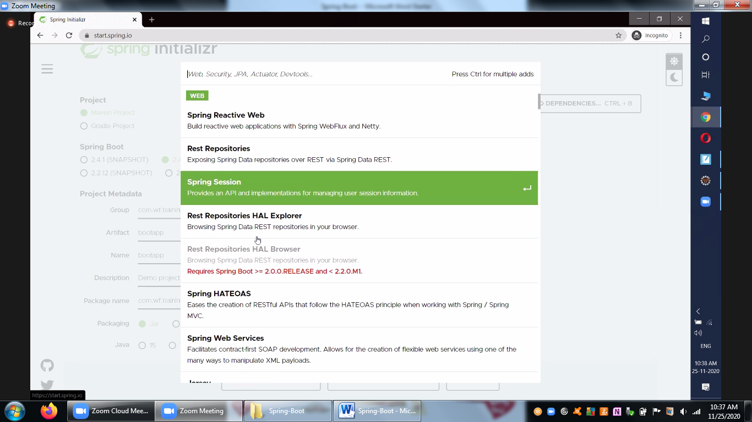

Select Web project and add as dependency

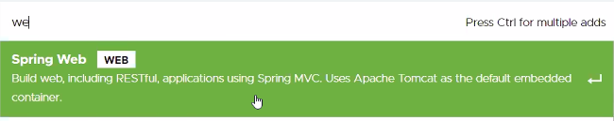

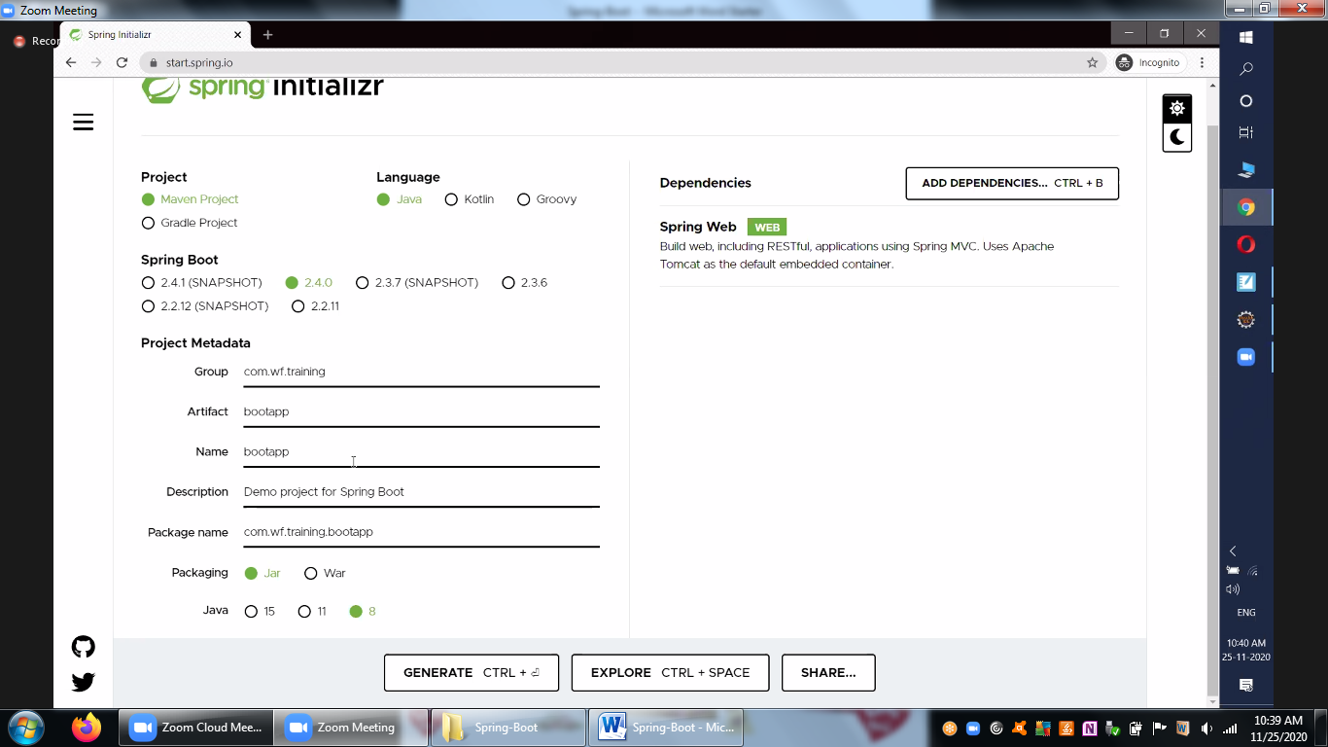

Click on the Generate CTRL and Place it in the workspace as below

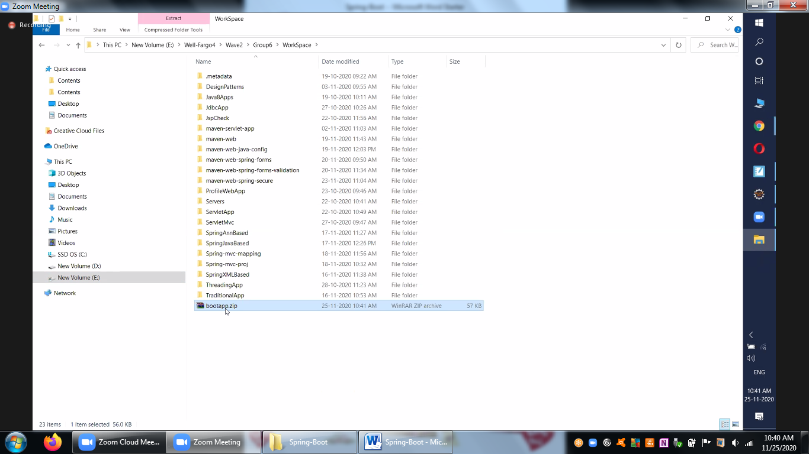

Import as Maven Project

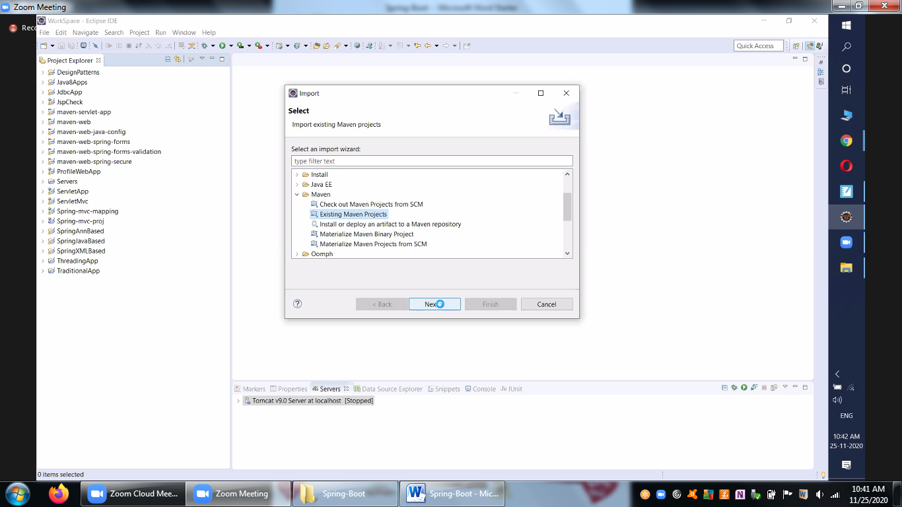

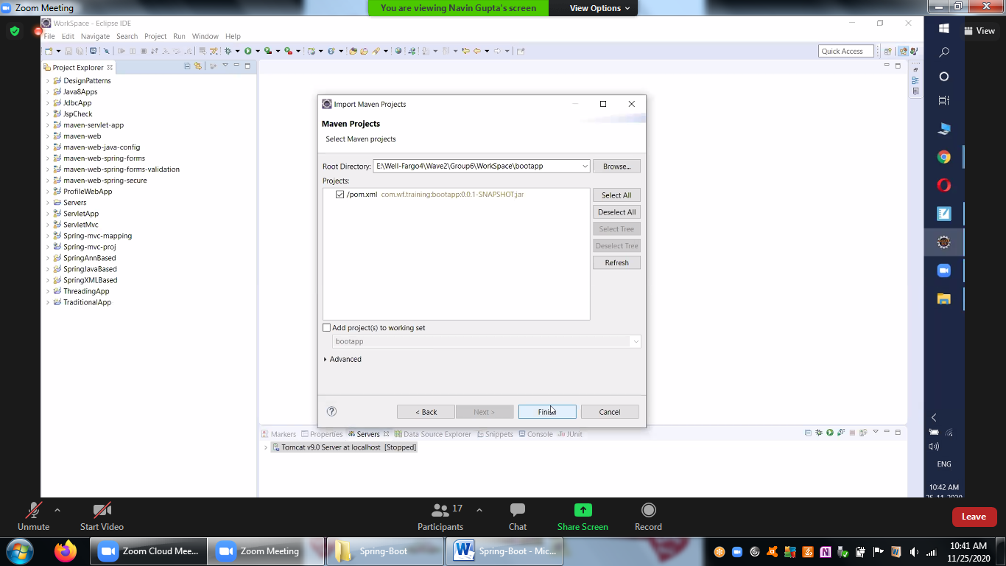

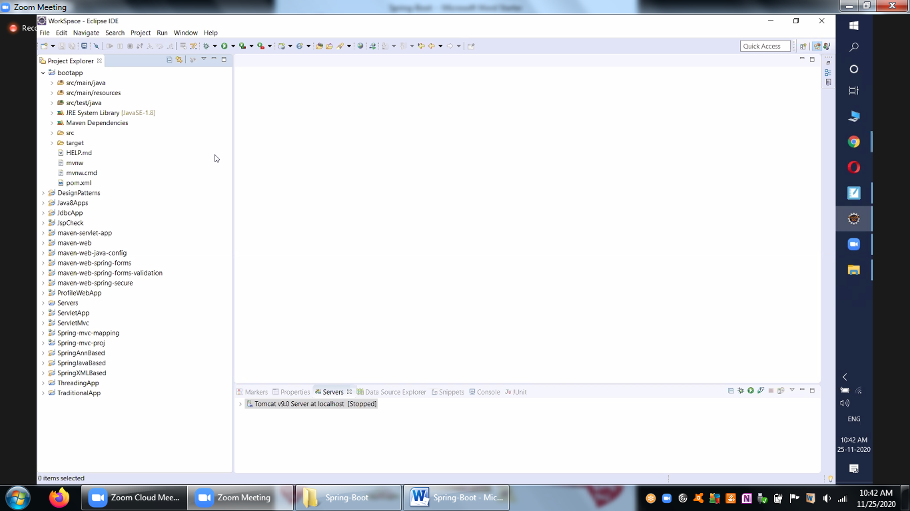

Dependencies Management

Existing Maven dependencies

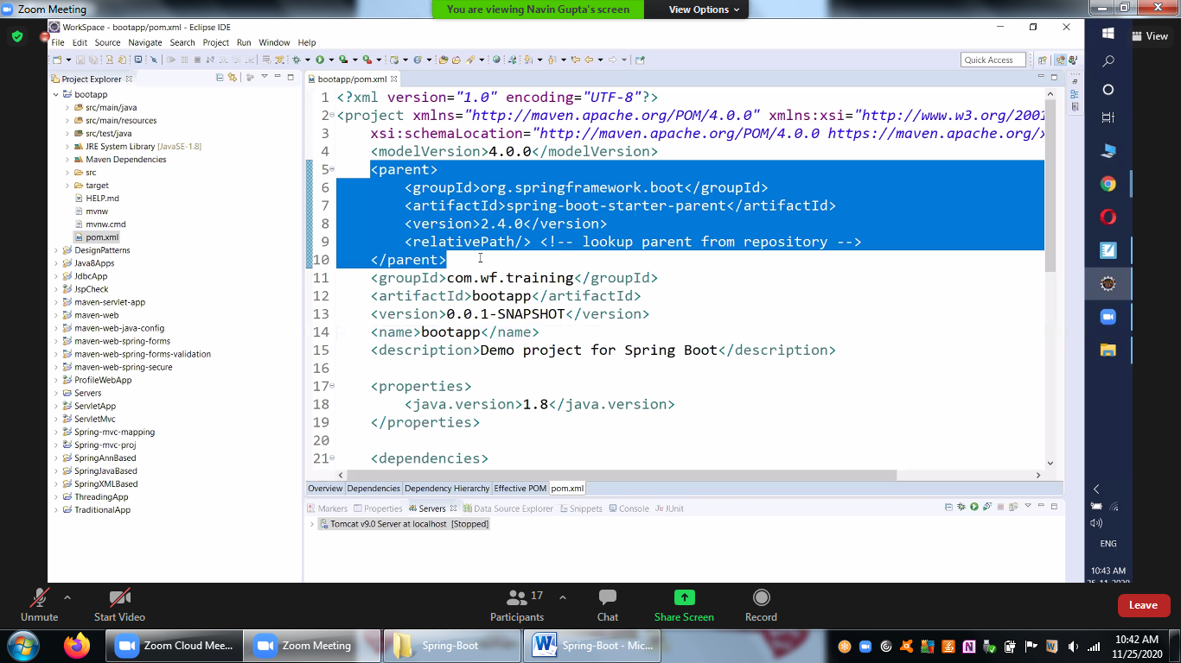

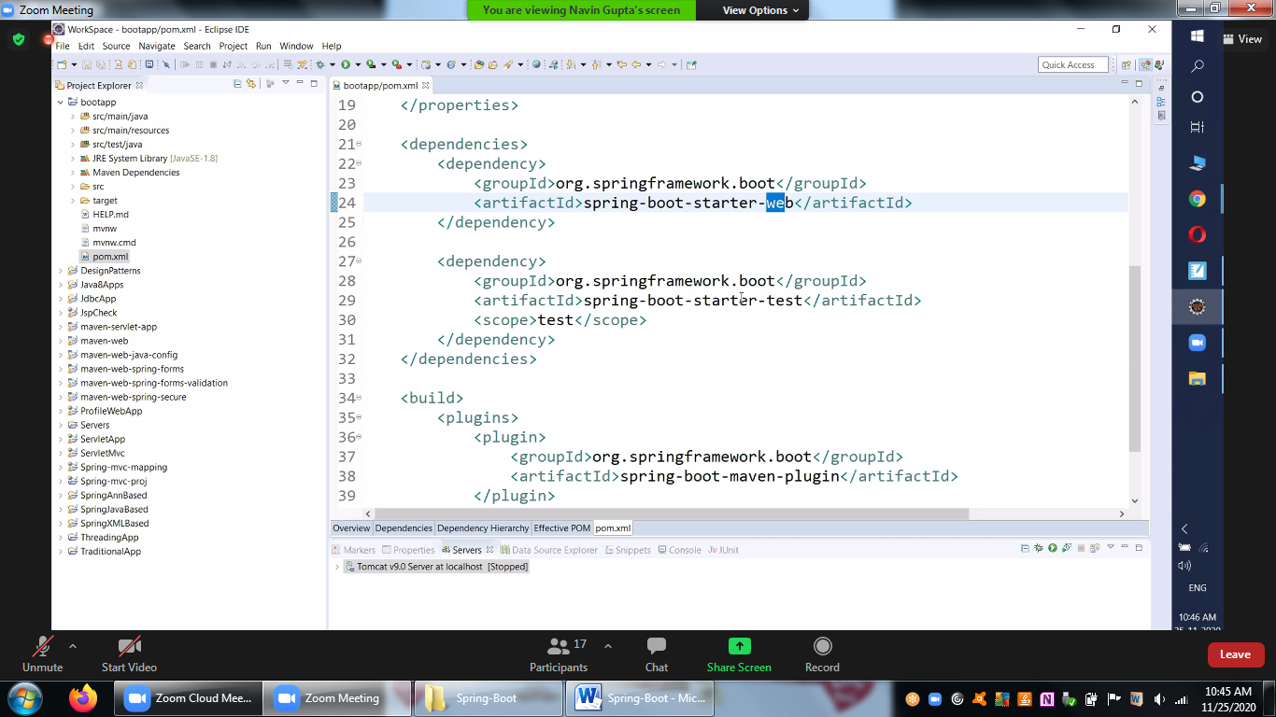

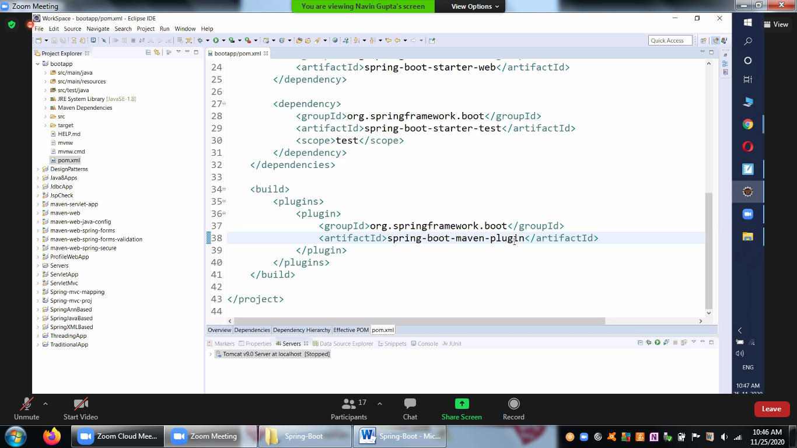

For Exploring you can go to Hierarchy Tab

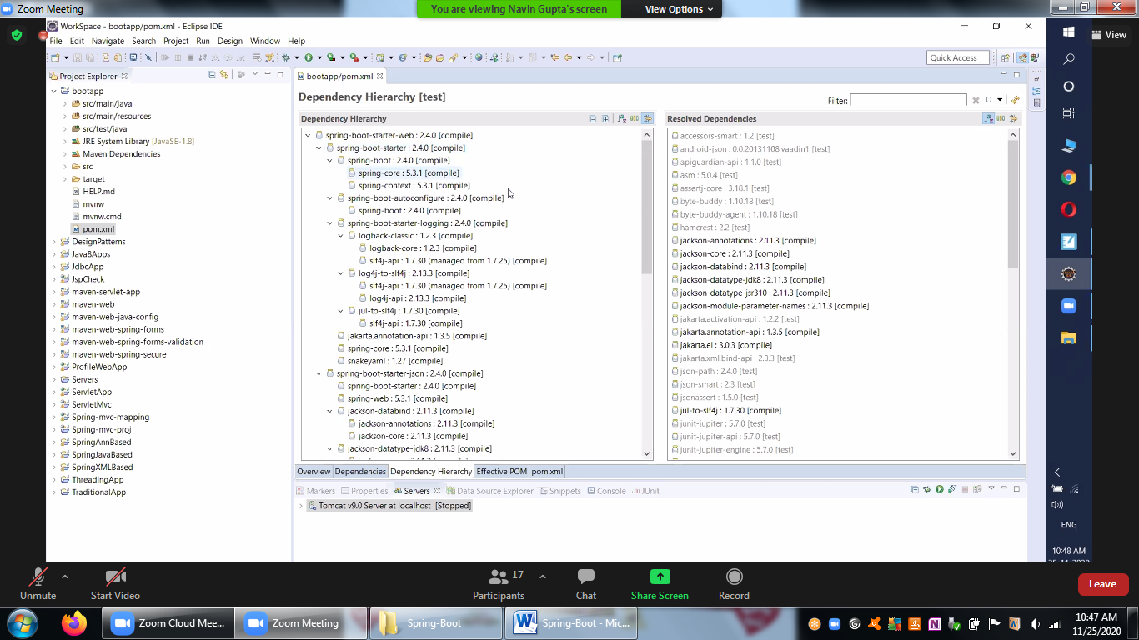

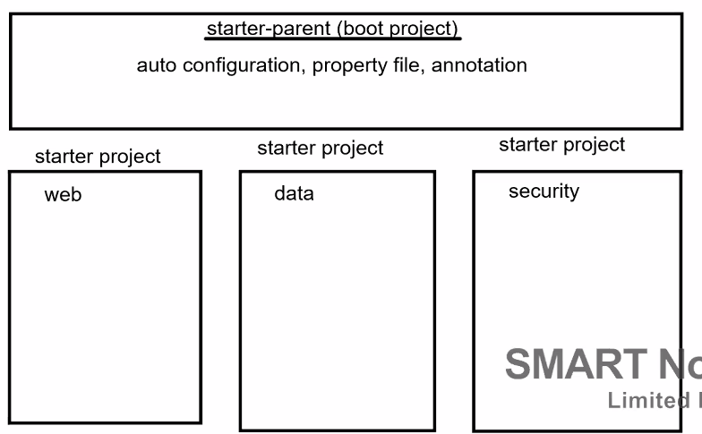

**Let’s talk about Self-Sufficiency**

Maven in-built support is below

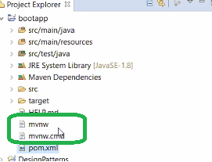

In built Java class along with configuration is already given

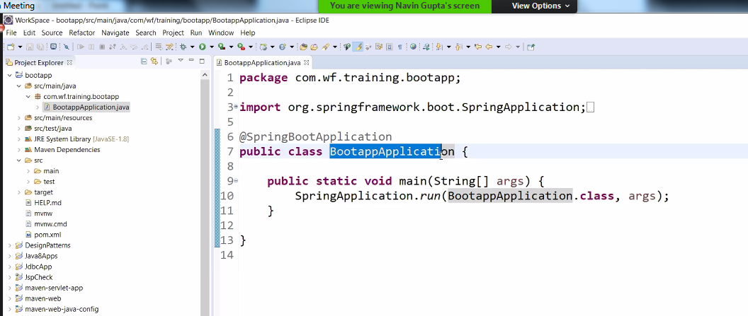

Explanation

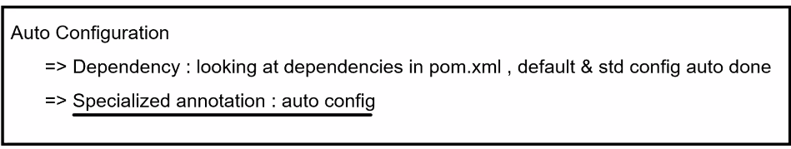

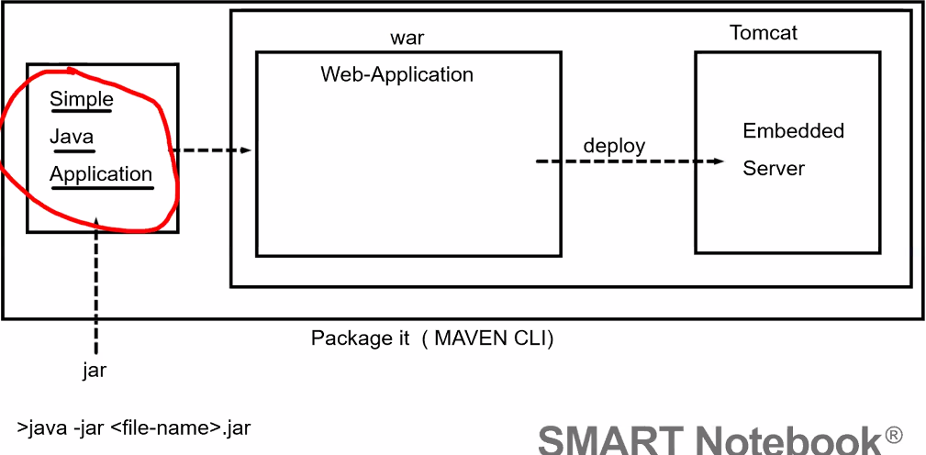

Just we have to focus on the Views, Model and Controllers (Business resources)

Create the Spring Resources which are specific for our project

Webapp folder

webapp folder is missing and it is expected, we don’t see the webapp folder for spring boot



Explanation:

We see new resoruces 3 folders and explanation is below

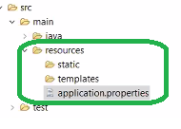

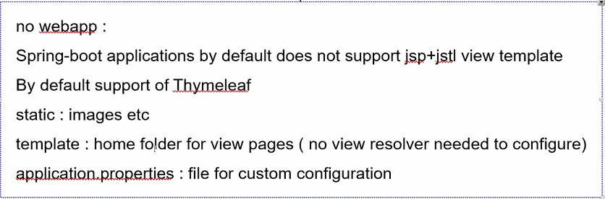

Add index.html for basic test scenario

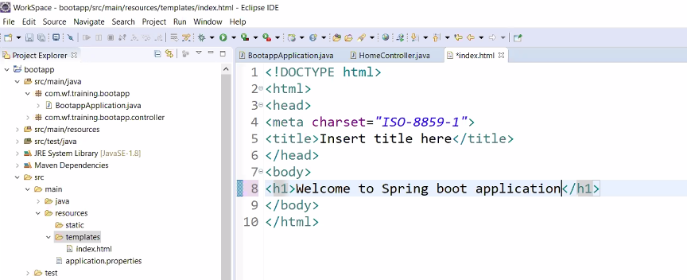

Add the dependency of ThymeLeaf

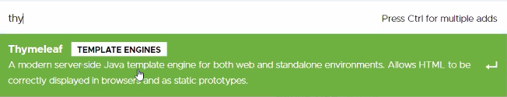

Click on the Explore button, Copy and add the same to our project POM.xml

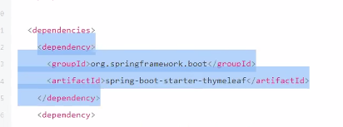

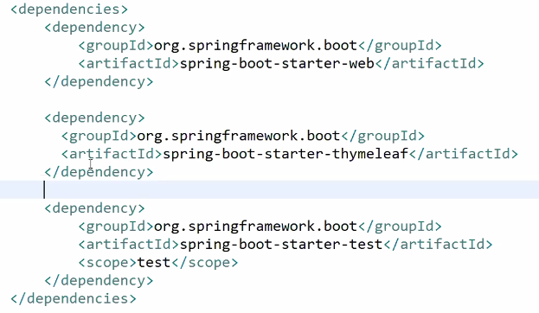

Run our Application and Run as Java application

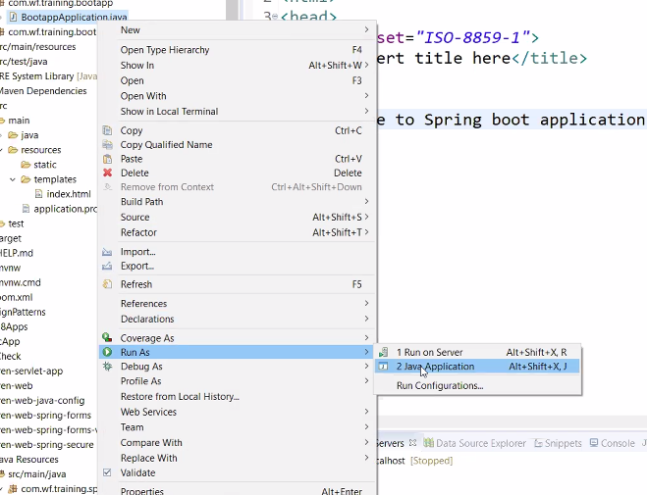

We may get this error

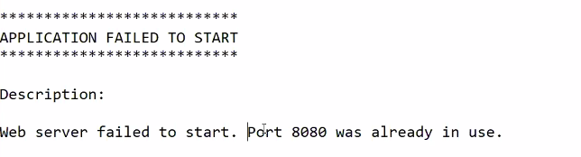

Configure the port number for the embedded Tomcat

Here application.properties plays a vital role, add the below key value pair in properties file

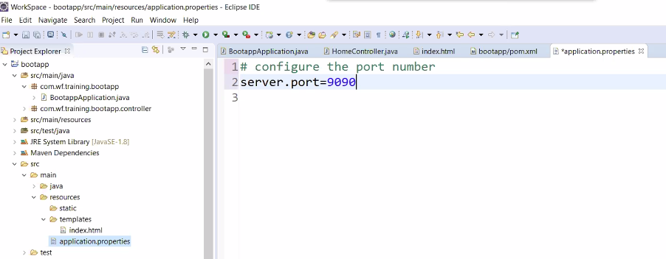

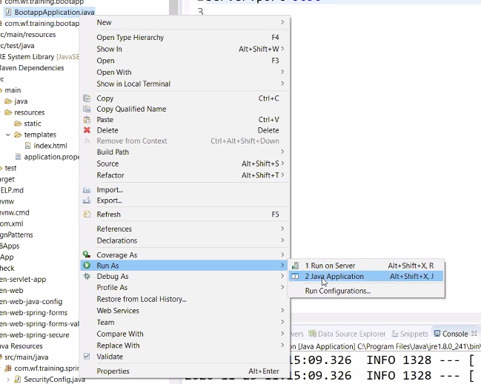

We have to enter the URL and launch the chrome manually. Now its success.

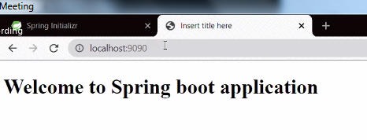

**….Basic Configuration is success and completed now….**

Adding JSP-JSTL dependencies from mvvrepository

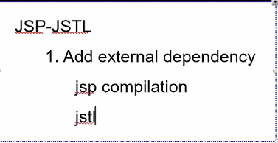

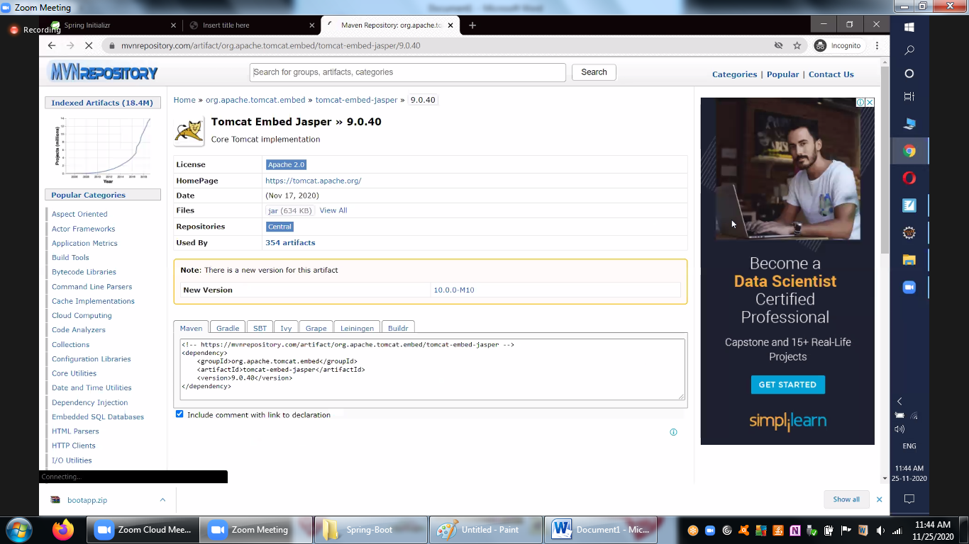

Remove Timeleaf and add the JSP and JSTL

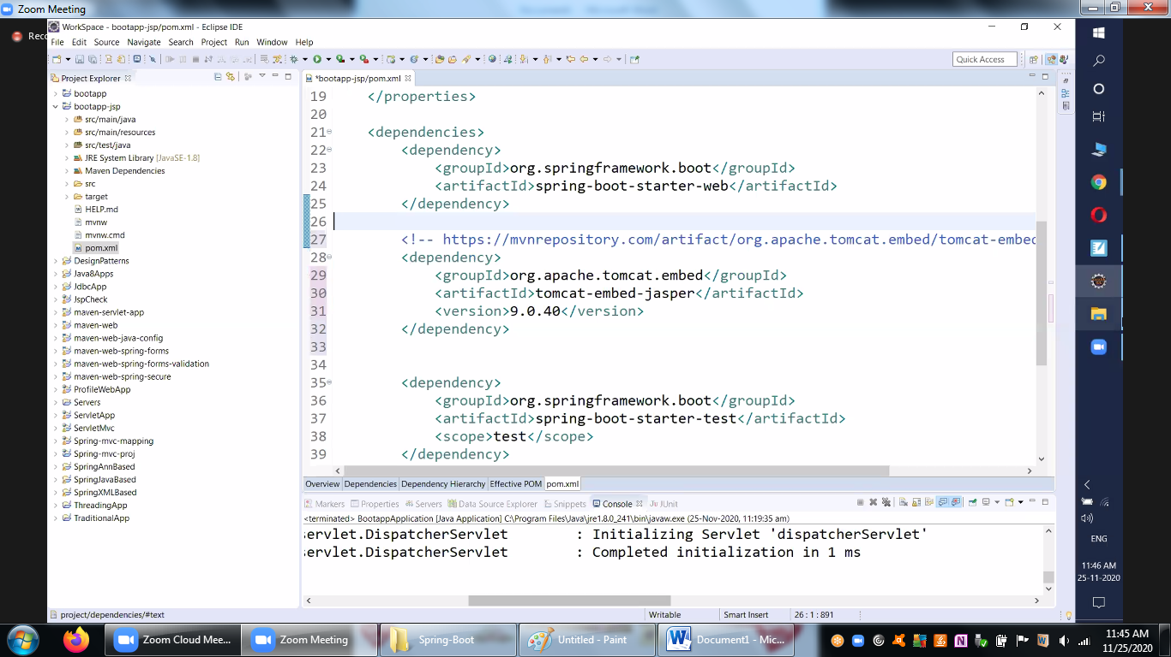



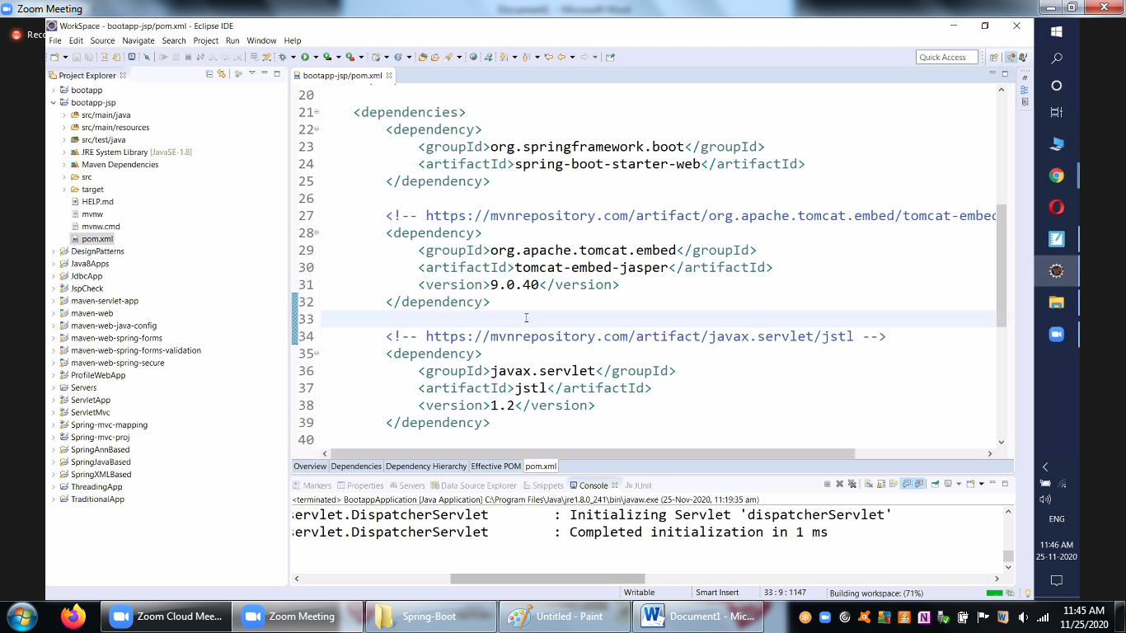

Add the webapp folder structure explicitly

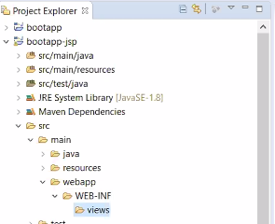

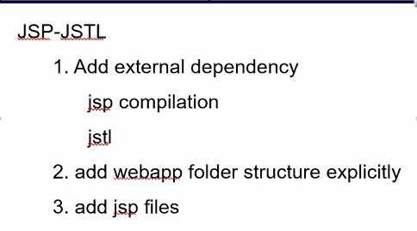

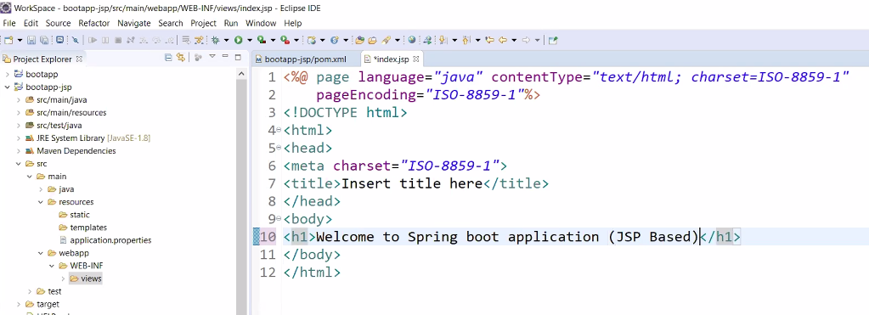

Add the Custom Config View Resolver, The same can be done using the properties file

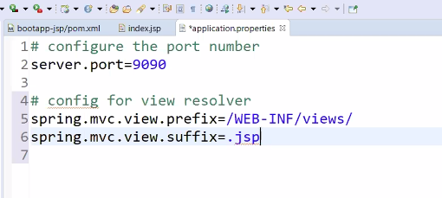

Run as Java application and its success now

